**EXP 23 : ONLINE SHOPPING SYSTEM**

**USE CASE DIAGRAM:**

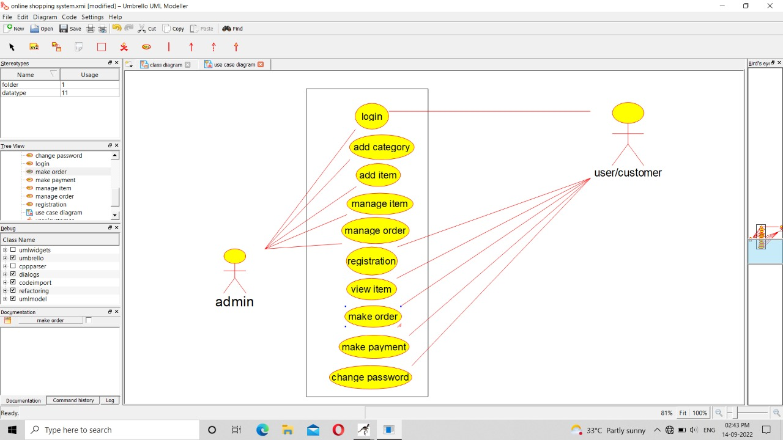

**CLASS DIAGRAM:**

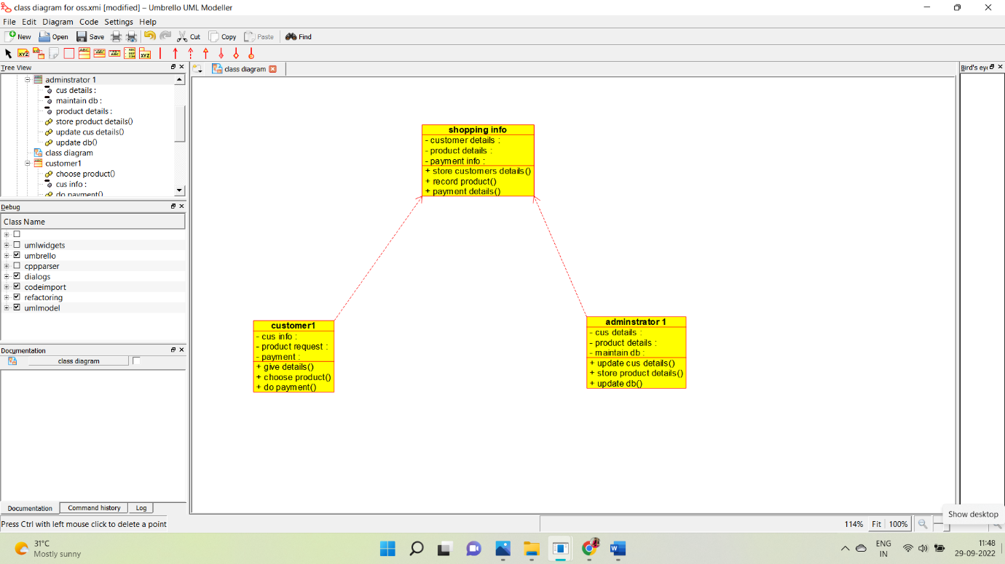

**ACTIVITY DIAGRAM:**

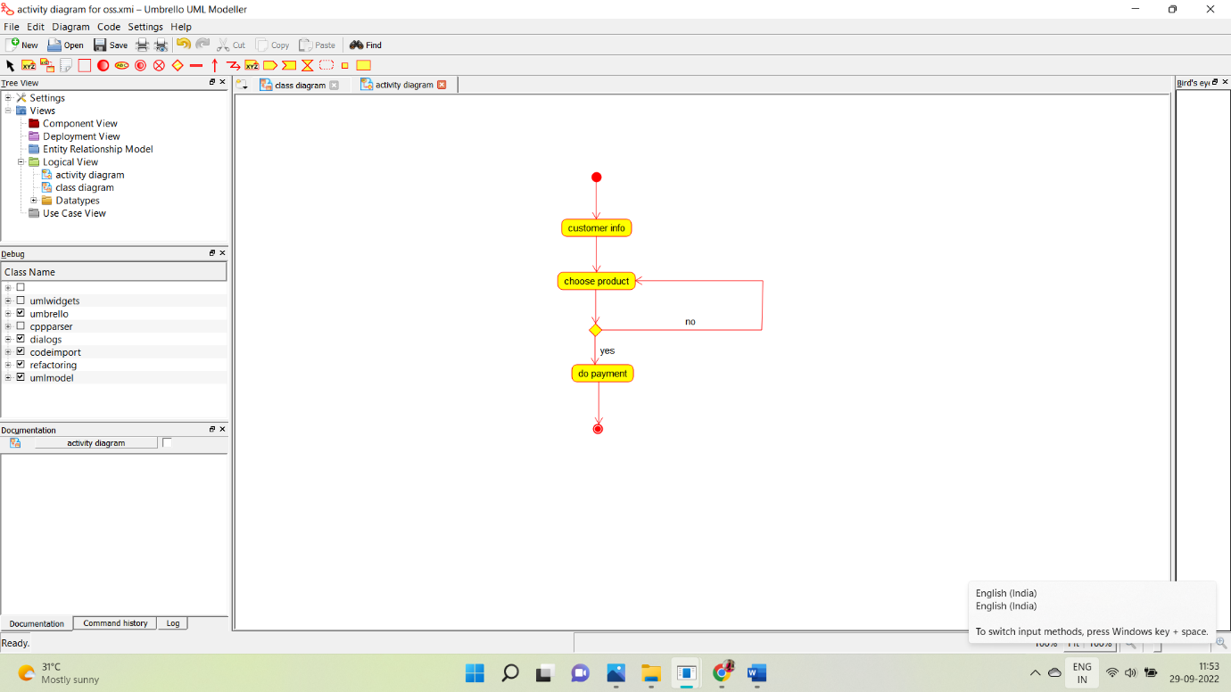

**SEQUENCE DIAGRAM:**

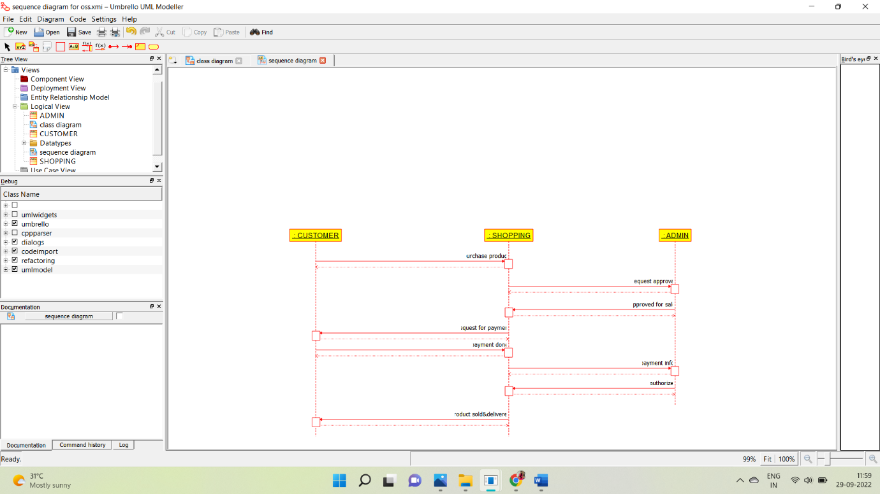

**COLLABORATION DIAGRAM:**

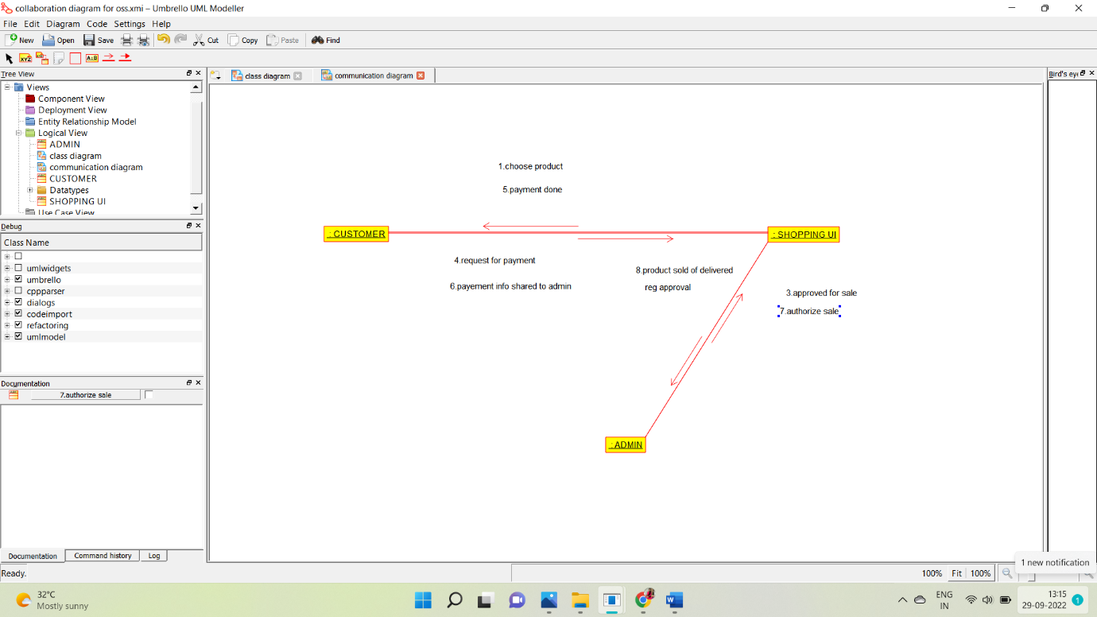

**STATE CHART DIAGRAM:**

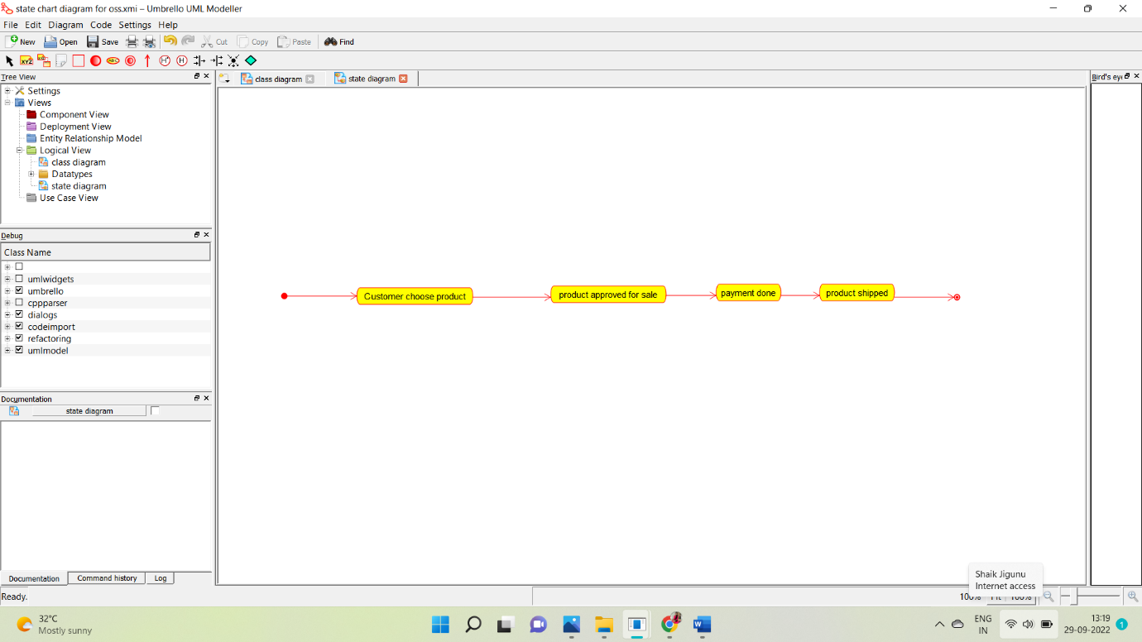

**COMPONENT DIAGRAM:**

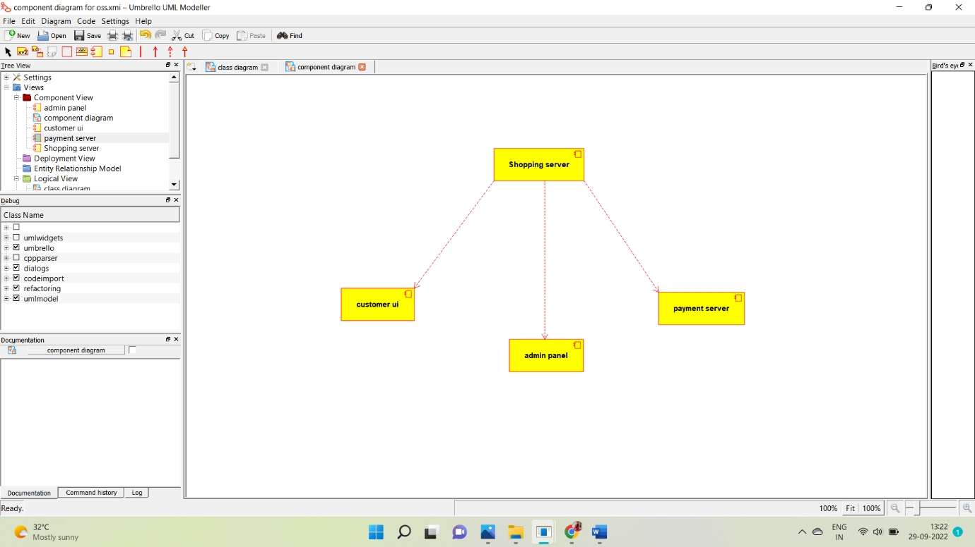

**DEPLOYMENT DIAGRAM:**

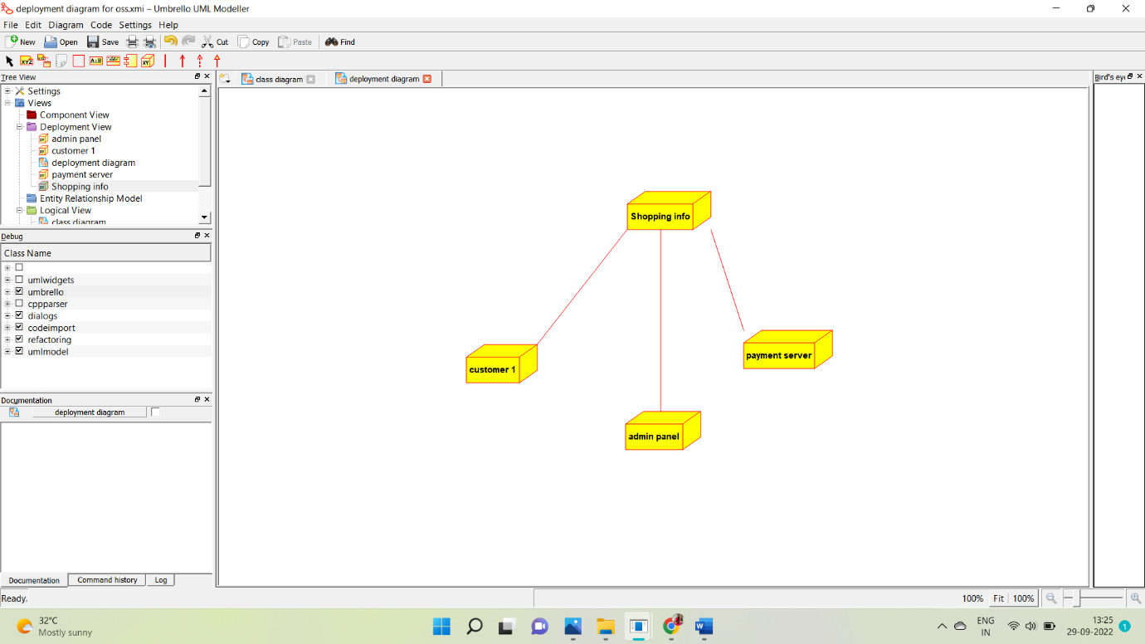

**PROGRAM:**

**/\*\***

**\* Class shopping_info**

**\*/**

**public class shopping_info {**

**//**

**// Fields**

**//**

**private void customer_details;**

**private void product_details;**

**private void payment_info;**

**//**

**// Constructors**

**//**

**public shopping_info () { };**

**//**

**// Methods**

**//**

**//**

**// Accessor methods**

**//**

**/\*\***

**\* Set the value of customer_details**

**\* @param newVar the new value of customer_details**

**\*/**

**private void setCustomer_details (void newVar) {**

**customer_details = newVar;**

**}**

**/\*\***

**\* Get the value of customer_details**

**\* @return the value of customer_details**

**\*/**

**private void getCustomer_details () {**

**return customer_details;**

**}**

**/\*\***

**\* Set the value of product_details**

**\* @param newVar the new value of product_details**

**\*/**

**private void setProduct_details (void newVar) {**

**product_details = newVar;**

**}**

**/\*\***

**\* Get the value of product_details**

**\* @return the value of product_details**

**\*/**

**private void getProduct_details () {**

**return product_details;**

**}**

**/\*\***

**\* Set the value of payment_info**

**\* @param newVar the new value of payment_info**

**\*/**

**private void setPayment_info (void newVar) {**

**payment_info = newVar;**

**}**

**/\*\***

**\* Get the value of payment_info**

**\* @return the value of payment_info**

**\*/**

**private void getPayment_info () {**

**return payment_info;**

**}**

**//**

**// Other methods**

**//**

**/\*\***

**\*/**

**public void store_customers_details()**

**{**

**}**

**/\*\***

**\*/**

**public void record_product()**

**{**

**}**

**/\*\***

**\*/**

**public void payment_details()**

**{**

**}**

**}**

**/\*\***

**\* Class customer1**

**\*/**

**public class customer1 {**

**//**

**// Fields**

**//**

**private void cus_info;**

**private void product_request;**

**private void payment;**

**//**

**// Constructors**

**//**

**public customer1 () { };**

**//**

**// Methods**

**//**

**//**

**// Accessor methods**

**//**

**/\*\***

**\* Set the value of cus_info**

**\* @param newVar the new value of cus_info**

**\*/**

**private void setCus_info (void newVar) {**

**cus_info = newVar;**

**}**

**/\*\***

**\* Get the value of cus_info**

**\* @return the value of cus_info**

**\*/**

**private void getCus_info () {**

**return cus_info;**

**}**

**/\*\***

**\* Set the value of product_request**

**\* @param newVar the new value of product_request**

**\*/**

**private void setProduct_request (void newVar) {**

**product_request = newVar;**

**}**

**/\*\***

**\* Get the value of product_request**

**\* @return the value of product_request**

**\*/**

**private void getProduct_request () {**

**return product_request;**

**}**

**/\*\***

**\* Set the value of payment**

**\* @param newVar the new value of payment**

**\*/**

**private void setPayment (void newVar) {**

**payment = newVar;**

**}**

**/\*\***

**\* Get the value of payment**

**\* @return the value of payment**

**\*/**

**private void getPayment () {**

**return payment;**

**}**

**//**

**// Other methods**

**//**

**/\*\***

**\*/**

**public void give_details()**

**{**

**}**

**/\*\***

**\*/**

**public void choose_product()**

**{**

**}**

**/\*\***

**\*/**

**public void do_payment()**

**{**

**}**

**}**

**/\*\***

**\* Class adminstrator_1**

**\*/**

**public class adminstrator_1 {**

**//**

**// Fields**

**//**

**private void cus_details;**

**private void product_details;**

**private void maintain_db;**

**//**

**// Constructors**

**//**

**public adminstrator_1 () { };**

**//**

**// Methods**

**//**

**//**

**// Accessor methods**

**//**

**/\*\***

**\* Set the value of cus_details**

**\* @param newVar the new value of cus_details**

**\*/**

**private void setCus_details (void newVar) {**

**cus_details = newVar;**

**}**

**/\*\***

**\* Get the value of cus_details**

**\* @return the value of cus_details**

**\*/**

**private void getCus_details () {**

**return cus_details;**

**}**

**/\*\***

**\* Set the value of product_details**

**\* @param newVar the new value of product_details**

**\*/**

**private void setProduct_details (void newVar) {**

**product_details = newVar;**

**}**

**/\*\***

**\* Get the value of product_details**

**\* @return the value of product_details**

**\*/**

**private void getProduct_details () {**

**return product_details;**

**}**

**/\*\***

**\* Set the value of maintain_db**

**\* @param newVar the new value of maintain_db**

**\*/**

**private void setMaintain_db (void newVar) {**

**maintain_db = newVar;**

**}**

**/\*\***

**\* Get the value of maintain_db**

**\* @return the value of maintain_db**

**\*/**

**private void getMaintain_db () {**

**return maintain_db;**

**}**

**//**

**// Other methods**

**//**

**/\*\***

**\*/**

**public void update_cus_details()**

**{**

**}**

**/\*\***

**\*/**

**public void store_product_details()**

**{**

**}**

**/\*\***

**\*/**

**public void update_db()**

**{**

**}**

**}**